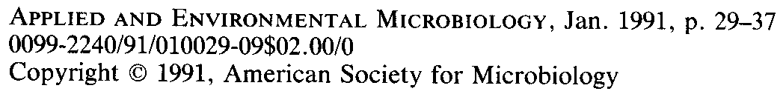
JANICE E. THIES, PAUL W. SINGLETON, AND B. BEN BOHLOOL*
University of Hawaii, NifTAL Project, 1000 Holornua Avenue, Paia, Hawaii 96779-9744
Received 1 August 1990/Accepted 14 October
1990
The ability to predict the symbiotic performance of rhizobia introduced into different environments would allow for a more judicious use of rhizobial inoculants. Data from eight standardized field inoculation trials were used to develop models that could be used to predict the success of rhizobial inoculation in diverse environments based on indices of the size of indigenous rhizobial populations and the availability of mineral N. Inoculation trials were conducted at five diverse sites on the island of Maui, Hawaii, with two to four legumes from among nine species, yielding 29 legume-site observations. The sizes of indigenous rhizobial populations were determined at planting. Soil N mineralization potential, total soil N, N accumulation and seed yield of nonnodulating soybean, and N derived from N₂ fixation in inoculated soybean served as indices of available soil N. Uninoculated, inoculated, and fertilizer N treatments evaluated the impact of indigenous rhizobial populations and soil N availability on inoculation response and crop yield potential. The ability of several mathematical models to describe the inverse relationship between numbers of indigenous rhizobia and legume inoculation responses was evaluated. Power, exponential, and hyperbolic functions yielded similar results; however, the hyperbolic equation provided the best fit of observed to estimated inoculation responses (r² = 0.59). The fact that 59% of the observed variation in inoculation responses could be accounted for by the relationship of inoculation responses to numbers of indigenous rhizobia illustrates the profound influence that the size of soil rhizobial populations has on the successful use of rhizobial inoculants. In the absence of indigenous rhizobia, the inoculation response was directly proportional to the availability of mineral N. Therefore, the hyperbolic response function was subsequently combined with several indices of soil N availability to generate models for predicting legume inoculation response. Among the models developed, those using either soil N mineralization potential or N derived from N₂ fixation in soybean to express the availability of mineral N were most useful in predicting the success of legume inoculation. Correlation coefficients between observed and estimated inoculation responses were r = 0.83 for the model incorporating soil N mineralization potential and r = 0.96 for the model incorporating N derived from N₂ fixation. Several equations collectively termed "soil N deficit factors" were also found to be useful in estimating inoculation responses. In general, models using postharvest indices of soil N were better estimators of observed inoculation responses than were those using laboratory measures of soil N availability. However, the latter, while providing less precise estimates, are more versatile because all input variables can be obtained through soil analysis prior to planting. These models should provide researchers, as well as regional planners, with a more precise predictive capability to determine the inoculation requirements of legumes grown in diverse environments.
Vol. 57, No. 1
29
Determining the need to inoculate is an important consideration in the cultivation of leguminous crops. Often the decision of whether to use inoculants is not predicated on any measurable factors of the environment but is divined through an analysis of legume cropping history or from previous success in improving yields with an inoculant. While these methods may provide a good basis for a decision in individual instances, they do little to elucidate the underlying mechanisms that determine inoculation responses. Without an understanding of the environmental factors that contribute to achieving a response to rhizobial inoculation, the successful use of an inoculant will remain a site-specific phenomenon. The ability to predict locations and legume species that will most likely respond to inoculation will enable decision-makers to make broader recommendations and direct resources where they are needed most.
Several inoculation trials have been conducted to identify
the factors that contribute to the success or failure of rhizobial inoculants in improving legume yields (2, 10). However, the failure to correctly identify or quantify the primary independent variables determining inoculation responses has hampered the use of these results to generate predictions regarding the performance of inoculants under various environmental conditions. Cropping history (2), magnitude (7, 9, 10) and effectiveness (7) of indigenous rhizobial populations, soil N availability in relation to legume N requirements (4, 9), and environmental constraints, which interact with management inputs to determine legume yield potential and N requirements (6), all significantly influence inoculation responses. Therefore, it is the interaction among these factors that will ultimately determine the likelihood and magnitude of inoculation responses.
From the results of inoculation trials conducted at several sites on the island of Maui, Hawaii, that varied greatly in soil N availability and soil rhizobial populations, the relationship
between the inoculation response and the size of the indig-
enous rhizobial population was mathematically described and quantified. The resulting single-variable response regres-
* Corresponding author.
†Journal series no. 3495 of the Hawaii Institute of Tropical Agriculture and Human Resources.
Modeling Symbiotic Performance of Introduced Rhizobia in the
Field by Use of Indices of Indigenous Population Size and
Nitrogen Status of the Soil†
30 THIES ET AL.
APPL. ENVIRON. MICROBIOL.
sion was subsequently combined with measures of soil N availability to generate predictive models for determining the magnitude of the increase in legume yield likely to result from rhizobial inoculation. These models provide the predictive capability needed to determine the inoculation requirements of legumes grown in diverse environments and are based on measurements of independent soil and microbial properties.
MATERIALS AND METHODS
Field inoculation trials. Eight field inoculation trials were conducted at five well-characterized sites on the island of Maui, Hawaii, from August 1986 to May 1988 (9). The site characteristics were as follows: elevation, 37 to 670 m; mean annual rainfall, 322 to 1,875 mm/year; mean soil temperature, 22.1 to 34.1°C; and mean air temperature, 18.6 to
VOL. 57, 1991
MODELING SYMBIOTIC PERFORMANCE OF RHIZOBIA 31
24.9°C. Site soils included two soil subgroups: Torroxic haplustolls and Humoxic tropohumults. No less than four but as many as seven legumes were planted at each site from among the following: Glycine max cv. Clark IV (nodulating and nonnodulating isolines; P. Creagan, U.S. Department of Agriculture, Beltsville, Md.); Phaseolus lunatus cv. Henderson's Baby; Vigna unguiculata cv. Big Boy or cv. Knuckle Purplehull; Phaseolus vulgaris cv. Bush Bountiful; Arachis hypogaea cv. Burpee Spanish or cv. McRan Valencia; Leucaena leucocephala cv. K-8; Lathyrus tingeatus (tinga pea); Medicago sativa cv. Florida 77; and Trifolium repens cv. Regal Ladino. This protocol yielded 29 legume species site observations. Crops were (i) inoculated at 10⁵ to 10⁷ cells seed⁻¹, depending on seed size, with an equal mixture of three effective strains of homologous rhizobia in a peat based inoculant; (ii) fertilized with urea at no less than 800 kg of N ha-1, applied at weekly intervals at a rate of 100 kg of N ha-1; or (iii) left uninoculated, with no N applied. Crops were grown under drip irrigation, the soil pH was adjusted when necessary (5.5 to 5.9), and nonlimiting amounts of nutrients were applied as described by Thies et al. (9). Inoculation trials were set up in a split-plot design with legume species in main plots and N source treatments in subplots. Economic yield was defined as seed yield at harvest maturity (3) for the grain legumes and total aboveground biomass for the forage legumes. The number of indigenous homologous rhizobia was determined by the most-probable-number (MPN) plant infection assay (8) from random field soil samples taken at planting as described previously (9).
Soil N availability. Soil mineral N available for plant growth was assessed with both laboratory methods and appropriate controls in the field inoculation trials (e.g., nonnodulating soybean isoline). Soil analysis yielded measures of soil N mineralization potential and total soil N (Table 1). Twenty five 2.54-cm cores to a depth of 25 cm of uncultivated field soil were taken from each field site. Soil cores from each site were combined, mixed thoroughly, sieved through a 2.8-mm mesh screen, and air dried for 4 days prior to analysis. Soil N mineralization potential was determined in an incubation assay conducted at 40°C for 7 days under waterlogged conditions (5). Total soil N was
determined by micro-Kjeldahl digestion (1). Crop measures of soil N availability included N accumulation and seed yield of nonnodulating soybean and N derived from N₂ fixation in inoculated soybean (Table 1). Nitrogen accumulation by nonnodulating soybean (kilograms hectare-1 day-1) was determined by dividing total N uptake (seed N plus stover N) (kilograms hectare-1) at harvest maturity (3) by the crop duration (days). Percent N derived from N₂ fixation was determined by subtracting total N accumulated at harvest maturity by nonnodulating soybean from that accumulated by inoculated soybean and converting the result to a percentage.
Model development. Economic yield increase due to inoculation was converted to percent increase to eliminate differences in the yield potential of the nine legume species as a variable. The relative inoculation response at each site was therefore expressed as the percent increase in the mean yield of inoculated crops (I) over that of uninoculated (U) crops: [(I-U)/U] x 100. The relative response was regressed against 1 + the number of indigenous soil rhizobia as counted in the MPN plant infection assay to find the best mathematical description (BMD) of the relationship between these two variables. Regression analysis with the BMD was performed on an individual-site basis to generate a table of y intercept coefficients. These coefficients were regressed against measures of soil N availability to determine the mathematical relationship between these coefficients and available soil N. Mathematical expressions incorporating measures of soil N availability were then substituted for the y intercept coefficients in the BMD to produce predictive models for legume responses to rhizobial inoculation. All analyses were performed with the nonlinear regression and correlation analysis modules of SYSTAT version 4.0 (11).
RESULTS AND DISCUSSION

The legume response to rhizobial inoculation was inversely related to the number of indigenous rhizobia. The abilities of linear, logarithmic, quadratic, power, first-order exponential, and hyperbolic expressions to describe this relationship were evaluated (Table 2). The BMD was selected by comparing residual mean square values from these
32 THIES ET AL.
regression analyses and coefficients of linear correlation (r) between the observed inoculation responses and those predicted by the various equations. A higher sum of squares for regression was obtained for equations with lower residual mean square values. Higher r values indicated a closer fit to a 1:1 agreement between observed and estimated inoculation responses.
Power, first-order exponential, and hyperbolic functions yielded similar r values (Table 2); however, the hyperbolic equation was selected as the BMD because of its lower residual mean square; its less precipitous slope of the regression line, which allows for estimation of slightly greater inoculation responses over a wider range of indigenous rhizobial numbers; and its simplicity. This equation takes the following form: relative response = bo x [1/(1 + indigenous rhizobia)], where the relative response is the increase in yield due to inoculation (percent); indigenous rhizobia are the numbers of infective rhizobia g of soil-¹ as counted in the MPN plant infection assay; and bo, the slope coefficient, is the y intercept, which represents the maximum inoculation response predicted in the absence of indigenous rhizobia. A comparison of responses observed in the inoculation trials and those estimated by this equation is presented in Fig. 1.
The hyperbolic regression yields an r² of 0.59, indicating that 59% of the variation observed in inoculation responses could be accounted for by the inverse relationship of inoculation responses to numbers of indigenous rhizobia. The greater responses were observed when indigenous rhizobia numbered between 0 and 10 cells g of soil⁻¹ (Fig. 1). In this
APPL. ENVIRON. MICROBIOL.
range, there is a high probability that an inoculation response will be obtained as long as N is limiting crop yield. Little or no response is expected when the numbers of indigenous rhizobia are greater than 100 cells g of soil-1.
A large variation in the magnitude of inoculation responses was observed in the absence of indigenous rhizobia (Fig. 1). Inoculation responses in the absence of indigenous rhizobia represent soybean grown at five different sites. The observed variation was related to differences in site characteristics, particularly the quantity of soil N available for crop growth (Table 1).
A conceptual model for predicting the legume inoculation response is presented in Fig. 2. This model emphasizes the key roles played by plant symbiotic N demand and the ability of the indigenous rhizobial population to meet that demand. The model assumes that to realize benefit from rhizobial inoculation, there must be a demand for symbiotic N in the cropping system. In the absence of indigenous rhizobia, the magnitude of any inoculation response will be directly proportional to plant demand for symbiotic N, which is a function of crop growth potential in that system. The greater the demand, the greater the potential response to inoculation. If indigenous rhizobia are present and effective, they will satisfy a portion of this demand. The greater the proportion of symbiotic N demand met by indigenous rhizobia, the smaller the magnitude of any inoculation response. The hyperbolic equation can be used to describe these two effects and estimate the inoculation response by redefining the y intercept (bo) in terms of available soil N supply such that bo = function(soil N availability). It is assumed that the
VOL. 57, 1991
MODELING SYMBIOTIC PERFORMANCE OF RHIZOBIA 33
34 THIES ET AL.
APPL. ENVIRON. MICROBIOL.
quantity of soil N available will dictate symbiotic N demand. This relationship will not hold if yield is limited at a site by environmental factors other than N (Fig. 2).
A summary of the measures of soil N availability in the Maui inoculation trials is presented in Table 1. Significant relationships between bo values generated by hyperbolic regressions performed on the basis of site and both N mineralization potential and N derived from N₂ fixation are illustrated in Fig. 3. While linear, hyperbolic, and logarithmic functions may all be used to describe the relationship between N mineralization potential and these y intercept coefficients, the relationship is most nearly linear. The single point deviating from a linear relationship (Fig. 3A) was from a site at which factors other than N were the major limitations to yield, for there was no significant difference in yield among the uninoculated, inoculated, and fertilizer N treatments at this site (9). When this point is excluded from the analysis, correlation coefficients for linear, hyperbolic, and logarithmic relationships between soil N mineralization and bo values become r = 0.92, r = 0.75, and r = 0.86, respectively. The relationship between N derived from N₂ fixation and bo values for each site is best described by an exponential equation, although both linear and parabolic relationships were highly significant (Fig. 3B). Significant linear relationships were also obtained among bo values for each site, N accumulation and seed yield of nonnodulating soybean, and total soil N (r = 0.85, r = 0.82, and r = 0.46, respectively). Substitution of these equations for the y intercept coefficient (bo) in the hyperbolic response regression yielded useful predictive models (Table 3).
The models can be evaluated by comparing residual mean square values and the correlation (r) between observed inoculation responses and those estimated by each function (Table 3). Incorporating expressions of N availability into the hyperbolic response model improved agreement between observed and estimated inoculation responses, as compared with the agreement obtained when the initial hyperbolic equation was used (r = 0.77) (Table 2). Of these expressions, the exponential equation involving N derived from N₂ fixation in soybean and the linear equation incorporating soil N mineralization potential may prove most useful in estimations of bo. A comparison between observed inoculation responses and regression lines generated by these two equations is shown in Fig. 4A and 4B. Substitution of bo with
expressions involving indices of available N acts to proportionally decrease estimated inoculation responses as N availability increases (and symbiotic N demand decreases), yielding better estimates and improving the agreement between observed responses and those estimated by the hyperbolic response model (Fig. 5B and 5C).
Nitrogen derived from N₂ fixation in soybean is the best estimator of a potential inoculation response in relation to soil mineral N status, because it is a direct expression of symbiotic N demand. Therefore, it not only reflects soil N availability but also integrates the effects of all other environmental variables on yield potential. Incorporating the exponential equation involving N derived from N₂ fixation in soybean into the hyperbolic response regression provided the best fit (r = 0.96) of observed to predicted values (Fig. 4B and 5C). The ability to predict the inoculation response with this equation and others relying on postharvest variables is limited and after the fact, however, because of the need to grow nonnodulating and nodulating soybeans at a site to obtain an estimate of nitrogen derived from N₂ fixation. The value of the equation incorporating soil N mineralization potential lies in the fact that all variables required in the model can be obtained through soil analysis prior to planting. Hence, this equation may prove more useful for those wishing to estimate the potential inoculation response of legume crops introduced into new areas.
Another approach to estimating symbiotic N demand involves the use of soil N deficit factors (Table 4). Expressions involving these factors use the difference between crop N demand and soil N supply to fractionally decrease the maximum predicted inoculation response such that bo = b₁ x [(N demand - N supply)/N demand], where bo is the y intercept in the hyperbolic response regression, b_{l} is the maximum predicted inoculation response (percent increase in economic yield), N demand is either N accumulation (kilograms of N hectare-1 day-1) or seed yield (kilograms hectare-1) of crops grown with no N limitation to yield (fertilizer N treatment), and N supply is either N accumulation (kilograms of N hectare-1 day-1) or seed yield (kilograms hectare-1) of nonnodulating soybean. N supply can also be estimated by use of N mineralization potential or total soil N. However, if either of these variables is used, the general equation is modified as follows: bo = bl x {[N demand - (b2 x N supply)]/N demand}, where b₂ is a
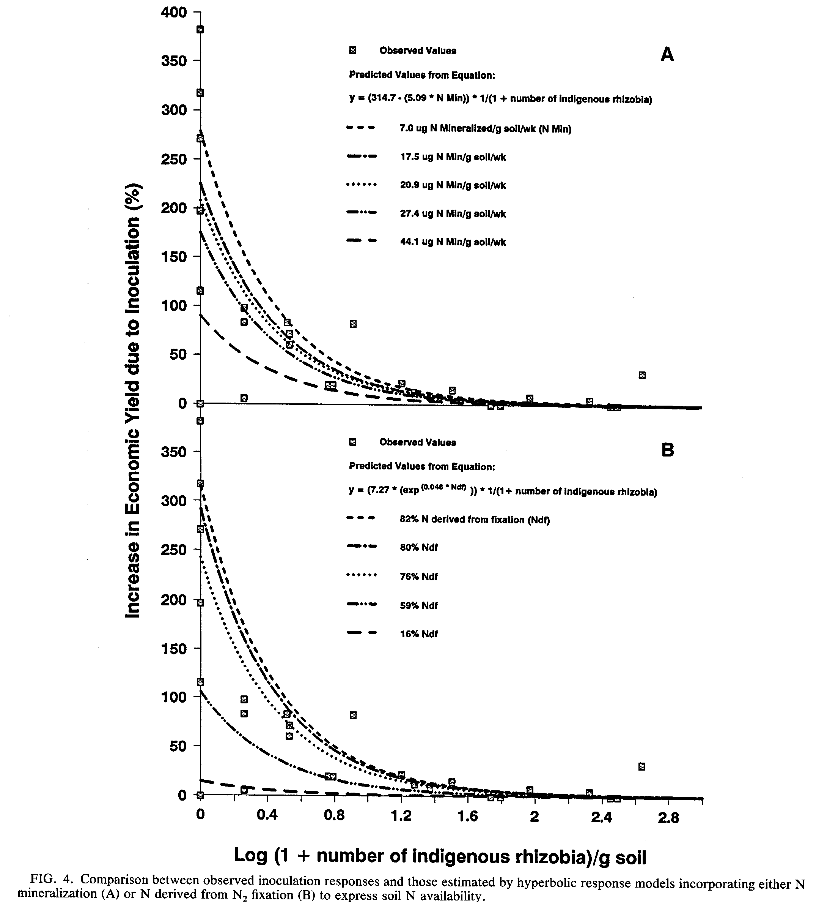
VOL. 57, 1991
MODELING SYMBIOTIC PERFORMANCE OF RHIZOBIA 35
coefficient that adjusts for the change in the units of measurement of N demand and N supply.
The lowest residual mean square value and best correlation between observed and estimated inoculation responses (r = 0.90) were achieved with the equation that uses seed yield to express both crop N demand and soil N supply
(Table 4). Although all of the equations incorporating soil N deficit factors provide reasonable inoculation response estimates, their usefulness is increased when actual yield data from regions of interest are used to provide input values.
In summary, inoculation responses were inversely related to numbers of indigenous rhizobia. This relationship was
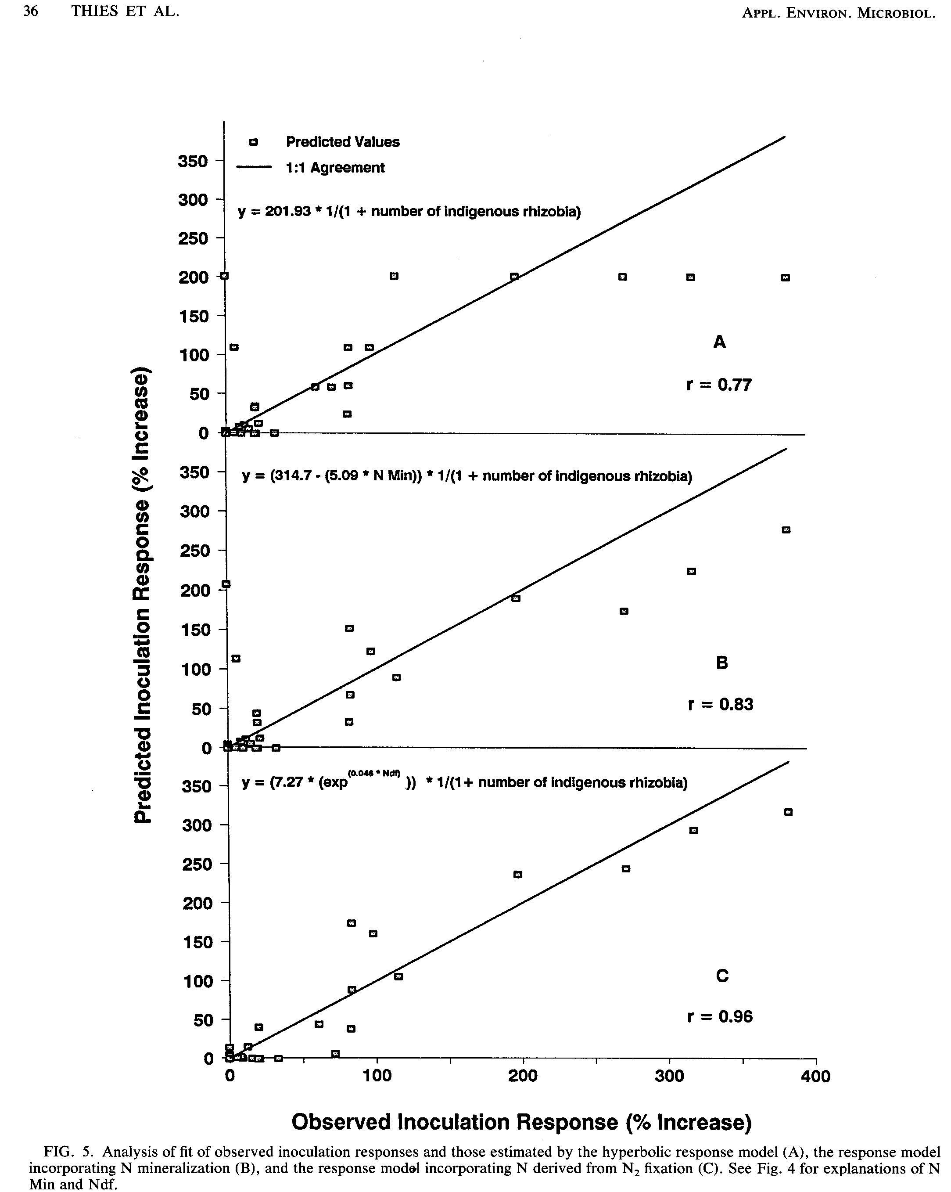
VOL. 57, 1991
MODELING SYMBIOTIC PERFORMANCE OF RHIZOBIA 37
best described by a hyperbolic equation. The fact that 59% of the observed variation in inoculation responses could be accounted for by the relationship of inoculation responses to numbers of indigenous rhizobia illustrates the profound influence that the size of soil rhizobial populations has on the success of rhizobial inoculation. y intercept coefficients generated from the use of the hyperbolic equation based on site were significantly related to various measures of soil N availability. Significant relationships were quantified, and the resulting expressions were substituted for the y intercept (bo) in the hyperbolic equation to generate models for predicting legume responses to rhizobial inoculation. While predicted values from the model incorporating N derived from N₂ fixation, a postharvest variable, were most highly correlated with observed inoculation responses, their use in a predictive capacity is limited. On the other hand, the model that combines soil N mineralization potential with numbers of indigenous rhizobia, while providing less precise estimates of inoculation responses, is more useful, because all input variables can be obtained through soil analysis prior to planting. These models reduce the need to conduct multiple field inoculation trials to estimate the responses to inoculation that can be expected by farmers. They also provide the predictive capability needed by extension specialists making inoculation recommendations to farmers and by regional planners determining the inoculation requirements of legumes introduced into new areas and, in turn, the need for and capacity of inoculant production facilities in their areas.
Woomer for providing the framework for the conceptual model, and R. Caldwell for a helpful discussion on the use of reduction
functions.
REFERENCES
1. Bremner, J. M., and C. S. Mulvaney. 1982. Nitrogen-total.
Agronomy 9:595-624.
2. Elkins, D. M., G. Hamilton, C. K. Y. Chan, M. A. Briskovich, and J. W. Vandeventer. 1976. Effect of cropping history on soybean growth and nodulation and soil rhizobia. Agron. J. 68:513-517.
3. Fehr, W. R., C. E. Caviness, D. T. Burmood, and J. S. Pennington. 1971. Stage of development descriptions for soybean, Glycine max (L.) Merrill. Crop Sci. 11:929-931.
4. Gibson, A. H., and J. E. Harper. 1985. Nitrate effect on nodulation of soybean by Bradyrhizobium japonicum. Crop Sci. 25:497-501.
5. Keeney, D. R. 1982. Nitrogen--availability indices. Agronomy
9:711-733.
6. Singleton, P. W., H. M. Abdel Magid, and J. W. Tavares. 1985. Effect of phosphorus on the effectiveness of strains of Rhizobium japonicum. Soil Sci. Soc. Am. J. 49:613-616.
7. Singleton, P. W., and J. W. Tavares. 1986. Inoculation response of legumes in relation to the number and effectiveness of indigenous rhizobium populations. Appl. Environ. Microbiol. 51:1013-1018.
8. Somasegaran, P., and H. Hoben. 1985. Methods in legume Rhizobium technology. University of Hawaii, NifTAL Project, Paia.
9. Thies, J. E., P. W. Singleton, and B. B. Bohlool. 1991. Influence of the size of indigenous rhizobial populations on establishment and symbiotic performance of introduced rhizobia on field-grown legumes. Appl. Environ. Microbiol. 57:19-28.
10. Weaver, R. W., and L. R. Frederick. 1974. Effect of inoculum rate on competitive nodulation of Glycine max L. Merrill. II. Field studies. Agron. J. 66:233-236.
11. Wilkinson, L. 1988. SYSTAT: the system for statistics. SYS
TAT, Inc., Evanston, Ill.
ACKNOWLEDGMENTS
This research was supported by National Science Foundation grant BSR-8516822 and U.S. Agency for International Development Cooperative Agreement DAN-4177-A-00-6035-00 (NifTAL Project).
We thank G. Haines, K. Keane, and T. Walker for assistance in the field, D. Olsen for performing plant nitrogen analysis, P.

